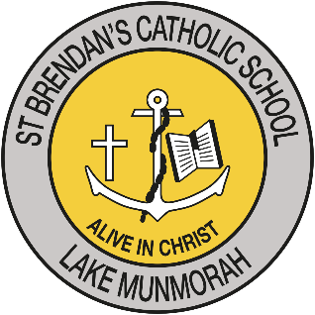

Enrolment Checklist – Years 1 & 2
Copies must be attached to application

Name of student:
Enrolment Form
Birth Certificate (certified copy)
(If not certified original and copy must be sighted together at School Office)
Sacramental Certificates to date
Passport, Visa, Citizenship documents if child born overseas (certified copy)
Current Family Court Orders (if applicable)
External test results – Speech, medical, IQ or special needs etc (if applicable)
Immunisation Certificate
Photograph/video Permission Form
K - 2 Internet and Network Services User Agreement
Release of Information Permission Form
Statement of Faith
Recent Photograph
Other

*Students must be enrolled under their registered name as stated on the Birth Certificate

